DESIGN OF MULTIVERSE Agent Based Model

@EC_GO May 8 2020

INTRODUCTION

This is an extension of the FIXED SPACE Agent Based Model called CovidSim, which provided parameters for simulating contagion-based epidemics within a fixed space, varying the lengths of time of incubation and asymptomatic infection, and the probability of contagion through movement by varying the Hazard Zone and mobility of persons.

The MULTIVERSE will accommodate a number of such Fixed Universes, which interact with one another through the movement of entities (persons) between them.

FUNDAMENTAL ELEMENTS OF THE DESIGN

Essentially, there are UNIVERSES (or spaces), and there are PERSONS, that move between the Universes. From these alone we propose attributes and mechanisms which will give this model sufficient power to simulate the dynamics of the communities we live in, within various contexts.

A UNIVERSE has the same dynamics of contagion (based on two PERSONS occupying overlapping space, given their Hazard Sizes), with three kinds of occupants:

* RESIDENT
* ATTACHED
* TRANSIENT and, in addition, an
* OVERALL MINGLE FACTOR

For example, a cruise ship or submarine is a UNIVERSE which is totally RESIDENT. A Long Term Care facility has mostly RESIDENTS, and some ATTACHED staff, and TRANSIENT visitors. An NFL game has mainly TRANSIENTS with some ATTACHED staff. An airport is mainly TRANSIENT with some attached staff. So the mix can be varied. Some places have more MINGLING than others: a conference reception would have a high mingle factor, a CRA payment office a low mingle factor. An airport would have a low mingle factor in terms of transients speaking or touching one another, but high if one took all common physical surfaces into account.

These are not the PERSONs. The PERSONs (in groups) must have the following characteristics:

* Roles (Fixed, Attached, Transient)
* Length of Stay
* Mingle Factor
* Itinerary

At a particular UNIVERSE, a PERSON might be a Resident, or be Attached, or be Transient; within that UNIVERSE, the PERSON has a specific Length of Stay, and from that UNIVERSE, the PERSON would follow their itinerary, which would have to be at times a choice (perhaps stochastic) of next destination. For example, after work at a meat packing plant, a PERSON might go to a communal shower and locker room, then to choice of {bar, gym, restaurant} 🡪 {ball game, bar, home} 🡪 {work, ER, clinic}

It is not necessary in this model to be specific about which bar, or which clinic. In fact, we do not need to specify “bar” or “restaurant” as much as needing to characterize a UNIVERSE/place by its characteristics of the ratio of population groups.

A PERSON may be a mingler in one context (working as a circulating food presenter at a reception, or nurse in ER), and a loner in another (library, home).

MORE FORMALLY

A UNIVERSE U has properties [F,A,T,M} F,A,T are ROLEs

* F = fixed resident %
* A = attached %
* T = transient %
* M = mingle factor

A PERSON p has properties:

* Roles R R(p): {F,A,T] = f(U) different States in different places
* Length of Stay L L(p): f(S(p), U) different Stays in places and roles
* Mingle Factor M(p): f(S(p), U) different mingling as function of U,R
* Itinerary list of (U[R,L,M], {Ui / Uj / Uk}, Ut, Uh)

We would not attempt to represent individuals uniquely but stochastically within groups that move from UNIVERSE to UNIVERSE. The attributes from CovidSim would of course still apply (uninfected, incubating, infectious, detected, Hazard Radius, risk factors, susceptibility).

DYNAMIC EXECTION

Within each UNIVERSE, the rules of contagion would apply as in CovidSim. At the start of an execution cycle, the new arrivals would be integrated into the Universe. At regular intervals (like punching the clock for shifts), the system would allow each UNIVERSE to deal with the PERSONs whose Length of Stay has been fulfilled, and a new destination determined according to the PERSON’s Itinerary.

The departures would be in the form of messages into the INBOXes of the UNIVERSEs in question. The system would then remove the departures from the UNIVERSE, and integrate the newcomers from the INBOX of that UNIVERSE.

The system would then permit the UNIVERSEs to execute according to their internal rules.

The Mingle Factor for a UNIVERSE is a general base for movement of the PERSONs, which would either increment or be a minimum of the Mingle factors for each individual PERSON. For example, residents in Long Term Care may not mingle much, but during meal-times and events, they do so, while the tendency for each individual might be low.

SETUP for Universes and Population

This may be time-consuming, if the distributions are to have some approximation to the reality contexts being modeled. Nevertheless, we must first define the UNIVERSEs and their general characteristics, in terms of mixes of Fixed, Attached, Transient and Mingle Factors (and here we can add names to bring some reality to these abstract spaces).

Then we have to choose the population in terms of numbers and roles as they move from one Universe to another. This scale of this modeling might be challenging. For example, do poultry workers just mingle in the workplace and leave, or do they move to a common bath and locker room facility and then leave?

For each group of PERSONs (drawn from the total population being modeled) we have to define which groups have some concrete identity in our planning, so we can plan their itineraries in terms of the UNIVERSEs they move to, and in those what Roles they play (they could move to the same UNIVERSE under a different role – for example, a flight attendant could be an airline passenger in the same simulation cycle).

This modeling of the Multiverse and its populations can be as micro-managed as one has the patience for, but the necessary level of detail should be driven by the questions being asked. If a detail is not necessary for the study, it should not be included. Simplicity is clearly going to be the mother of invention, in complex modeling systems such as this.

There can be inconsistencies in terms of time….could a group of PERSONs go to an office or manufacturing class Universe for 23 days and not leave? Well, the workers in an acrylic plant in Pennsylvania did exactly that, in order to produce the base materials for PPEs, in April.

If the inputs and outputs don’t balance, either the system is incorrectly programmed, or death stalks through the ghost in the machine.

STATISTICS

So what is going on in this simulated MULTIVERSE? The question is to ask how the epidemic is going in the complex UNIVERSEs? What does shelter in place mean in this model? It means that PERSONs become Fixed in an abstract space called “HOME’ with some mingling within but overall low, while the population put into circulation would be low.

Since the total uninfected, incubating, infected, and detected are carried by PERSONs, they can be cumulated at any time for the MULTIVERSE and for each UNIVERSE. The itineraries for each group of PERSONs (or stochastically, everyone), can be changed at any execution by the SYSTEM to implement a new policy of shelter in place, or of more testing (which shortens the periods before detection), or of the vaccine which changes the susceptibility, or closing down places (which removes certain UNIVERSEs in the abstract sense) or of opening up (which adds a UNIVERSE with characteristics to the itineraries).

It is clear that the system will have to be able to change all itineraries (much to the dismay of Republicans, but we can build in resistance too). So we want more people to go to mingle places – change their itineraries to make a certain % of PERSONs in age groups to visit two high mingle places before going to the low mingle HOME place for several cycles.

The fundamental tallies are going to be the numbers uninfected, incubating, infectious, detected at various points, the travel movements and the compositions of the UNIVERSEs as they change at each clock punch, and something we have not modelled – deaths and hospitalizations.

DEATHS and TAXES

We could move all detected to two rooms by adding in the function f(CoronaState🡪Detected Universe) and examine those detected in the Universe to send them to the Detected Universe.

The Detected UNIVErSE would be a Low Attached (staff) and High Transient (the patients) one, with the patients stochastically leaving after so many cycles to {Hospital U, ICU U, Death U, Home U} and from each of these we could have more stays and departures.

Perhaps we don’t need primitives except for the new departure-based-on-coronaState, and the rest can be modeled by the elements already designed. Cruise ships, quarantine camps, isolation, home shelter, parks, offices, construction sites, government agencies, can all be modeled using these design elements.

VALIDATION

It is going to be very difficult to use this as a predictive tool in terms of making a statement about excess deaths of so many people in Penticton if we open the Starbucks there.

This tool is intended to be an analytic model that shows effects in the sense of pushing on a lever and seeing an object rise at the other end of the fulcrum. It is intended to model effects, not predict numbers.

The future is never going to sit still and obey numbers that come from the past. However, if we had a model that reasonably allows us to state that if we had these kinds of spaces, and this kind of circulation of PERSONs, and they were to change, how would the needles move, and relatively speaking, how large or small are the effects?

These are the questions that the Covid Multiverse Agent Based Model hopes to address.

It is going to be tricky – if you open a football stadium with a mix of 90% transient and 10% staff, and you send a group of 15 PERSONs from HomeU to StadiumU, what if you forgot to send any P(transients) to it? You could choose to do that and simulate a no-audience game, or you could simulate a financial disaster (what if they gave a party and no one came) or you just plain forgot the population equations, or you implemented a free will-fear factor and PERSONs chose to stay home!

**DESIGN OF CSV SPECIFICATION FILES**

The first CSV file, which is named in the prototype as MVDATAge.csv, is a file that describes the movement of agents between universes, and the roles they have in them.

The second CSV file, which is named VL1.csv, identifies a subset of the agents in the MVDATAge.csv file as Covid cases, with viral loads, time since infection (since we are using the Temporal Dynamics and Viral Load model of Xi, He), and so on.

The program starts by requiring the use of the system to enter the population of agents corresponding to the schedule. If they do not match, there may be errors. The MVDATAge.csv persons are the for whom moves are proposed each cycle, and therefore viral transfer, viral growth, resizing are functions that are called for that population.

If the total population entered in the initial prompt is smaller than that of MVDATAge.csv, we will probably have execution errors from “undefined” array errors. If the total population is larger, the data tallies may be wrong, as the excess do not go to any universe but exist in pre-initialized state but are counted.

The program could check the match between them, but this requires error handling by the user. The program could change the CSV files to have a single multi-level parser, but that is a step for the future. As it stands, the system is bound to the FOUR steps. This is what appears after step 1 has been done.

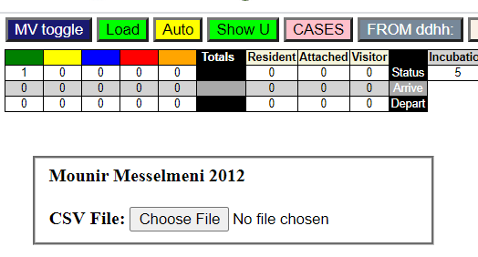

1. Input the correct population number at the startup prompt
2. Input the MVDATAge.csv file (or any other named file with data in the correct correspondence.
3. No positive correct loading is given. When control comes back to the user, click the “CASES” button and enter the VL1.csv file containing the initial cases.
4. PRESS THE LOAD BUTTON (in green). Sorry, but this is a crucial initialization step.

If the VL1.csv file is not entered, there are no infective agents, and the system will not simulate any epidemic.

MVDATAge.csv

Of course, the cvs file is created by an Excel table, saved in .csv format. The table entry looks like this:

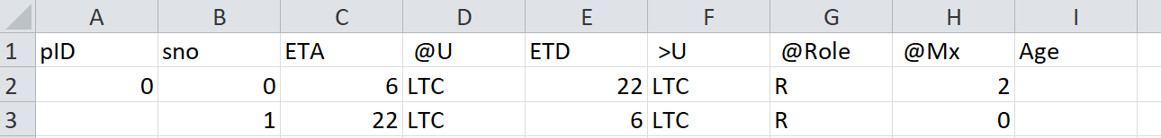

The pID field is the unique identifier for an agent (person, patient, class of persons, etc). The simplest approach is to number them from 0 to N.

This file describes the arrival and departure times for agents with respect to different universes (the maximum number is 9, for visualization purposes). The setting, M.UCt is a program variable, not an input parameter.

Think of the model of a master schedule for a train system. It knows about TIME (Days, Hours), Passengers, Arrivals, Departures. For each Passenger, the train reservation and scheduling system has a Journey profile with a number of stops, each with an ETA (expected to arrive) and ETD.

Thus, “sno” is the Stop Number for this passenger (0). Here we show two Stops (which may be thought of as ticket stubs). The ETA for pID=0 is at 0600hrs or 6am, and “@U” indicates the place that the person is at, or will be at, at 0600.

For initialization, this first set of tickets have no corresponding departure tickets which show their arrival on line 2 above. They land from zen-space at the ETA time, into the @U universe. Here we see that it is called “LTC” (for Long-Term-Care). The “ETD” field indicates the time that this person will be departing from @U, and the field “>U” shows the Universe to which that person will be going (which in this case, is also “LTC”, which means that person=0 will be staying there.

The “role” of this person for this duration is “R” which is “Resident” which means they will stay there permanently (long term care, hospitals, submarines, cruise ships, prisons; at a different level, these could be persons who do not travel by car, train, foot, air, or ship from a city, municipality, region, county, state).

The role “A” means “Attached” and these persons would be connected on a partial basis to the universe, such as staff who come for 8-hour shifts and leave. While there, their activity level (see below) is higher than for “residents”.

The role “V” stands for “Visitors”. Persons who visit patients in hospitals, who are outpatients in clinics, who are in transit in airports, students in schools and universities, are visitors. In general, they have less mobility and mingling or exposure to others than “Attached”.

“@Mx” is the mingle factor from 1 to 10, the higher the more active. This notion of activity is expressed the following way: at each cycle, for each person, a move from current location to another location is proposed, first stochastically according to random selection from a table of values which represents a Pareto distribution (more smaller numbers than larger – I suppose in theory the number should be randomly distributed in the table rather than clustered, as they are at present). Then the mingle factor is applied, in such a way that with the maximum of 10, the distance moved is still going to be within the bounds of the universe (if the universe had no bounds then everyone would disperse further and further away).

The calculation of the proposed move may also be subject to a mingle factor for the universe itself, but at present this is not a parameter but would have to be introduced through a modification of the calculation, though the field M.minglf is part of the Universe data definition already.

Essentially, the proposed move generates a pseudo-random walk (biased) for an agent, and the mingle factor increases the area covered by the random walk. Clearly a mingle factor of ZERO should cause the agent to remain in place, in which case the random walk covers an area of zero, and infection by contact cannot occur.

CovidSIMVL has the capability of defining a number of epicenters within a Universe, to which agents are stochastically drawn (but not magnetically)….thus, this feature could be used to represent persons in restaurants, coffee shops, bars, and receptions, in which most guests stay around a space, but the attendant staff mingle much more – same for students and Teaching Assistants.

The last field “Age” is for an age-group of the person. A function ageRisk(G,g) exists within the code for looking up an age risk table based on 10-year age groups, the population age distribution of BC for 2019, and the incidence distribution of age-group among Covid cases in Spain and Italy, with the risks ranging from 0.33 for age group 0 to 2.33 for age group 90+. Using the numbers is not clearly defined, so at present this calculation has been left out in the Temporal Dynamics – Viral Load model used in CovidSIMVL.

Here is another example:

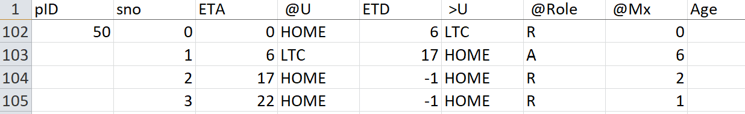

Person=50 has a role of “R” in @U=HOME from ETA=00 (midnight) to 0600 with a mingle factor of zero (sleeping), and leaves at that time for LTC. At LTC (line 103), arrival is at 0600 (instantaneous transport) and there, assumes a role of “A” (could stand for Attendant), with a mingle factor of 6.

At 1700 hours, P(50) arrives at HOME and there is not departure (-1) in this ticket, but now assumes a role of “R” – resident with a mingle factor of 2. The next ticket (sno=3) at 2200 again without departing, changes the mingle factor to 1 (getting ready for bed), and then the ticket recycles to midnight (line 102) with departure at 0600 for LTC.

HANDLING TIME

ETA and ETD can be in the form of “DDHH” – what has been shown is just the HH. The calculation is to take this field, and use floor(ETA/100) as DD with remainder (ETA/100) as HH.

The routine called “conductor()” matches the next clock time with the times on the ticket stubs (sno) for the current DD, so that a specific schedule with Thursday being different can be constructed. Note that the default is for the schedule for the next day to use the current day if there is no explicit entry for the next day. This is how the one-day schedule becomes the default recurrent schedule if no explicit tickets for a day is found. I am not sure at this point how robust the testing is for this schedule by exception approach.

**VL1.csv File**

This file is a “Case” file and supersedes corresponding entries in the MVDATAge.csv data.

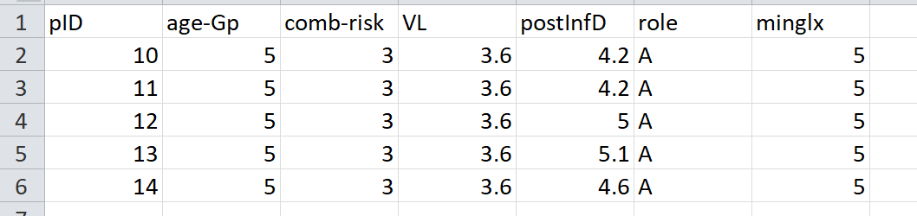

This example modifies the data for 5 persons, from P=10 to P=14. The first field, “pID”, is the unique identifier. The second is a duplicate field for age-group (and can be removed in time). The third is a combined-risk factor, to cover innate risk factors such as obesity, diabetes, asthma, vaping, hypertension, serious heart disease, chronic kidney disease, perhaps race. Rather than entering these in the simulation program, and requiring it to combine these risk factors, I have made the decision that this should be done better externally by the model creator, and combined into a single factor which affects the size (or viral growth? Or mobility?) of the person.

The “VL” field stands for Viral Load according to the Xi,He paper, using the CT times as score. The postInfD is important – this is the number of days after infection. For example, a newly infected person in the simulation could be given a number here of 1 but this would require the simulation to run for 1.9 days before the person becomes infective.

A creative example of this specification is to give the agent a mingle of 0, and a postInfD of 12.2d with a high viral load, say of 6. This then places the agent with 1 day left for infectivity, and immobility – exactly what a door knob would be.

These CSV files should be considered evolutionary, and their evolvement is inevitable.